
Year 10

End of Term 3 Test 2017
Total Marks: / 43
Instructions: Show all working clearly, in sufficient detail to allow your answers to be checked and for part marks to be awarded for reasoning.
Calculators and 1 side A4 note page are permitted.
Time Allocation: 55 mins working time 2 minutes reading time.

Question 1 (1 mark)
The box plot for the data set
1, 1, 2, 2, 3, 4, 5, 5, 6 is:

A
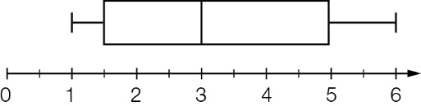

B
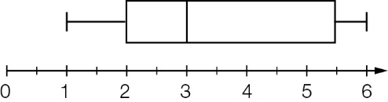

C
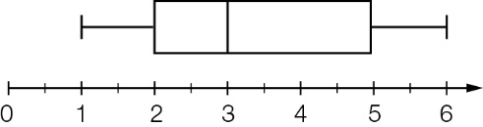

D
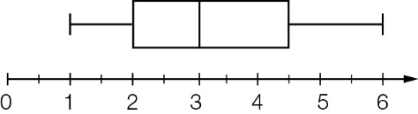

Question 2 (1 mark)
The key five values (minimum value, lower quartile, median, upper quartile, maximum value) of a particular data set are (16, 24, 31, 37, 65). Which of the following statements about the data is untrue?

A the interquartile range is 13
B 25% of the values lie below 24
C 75% of the values lie below 37
D the data set contains no outliers

Question 3 (5 marks)
(a) For each data set find (i) median (ii) range and (iii) interquartile range.

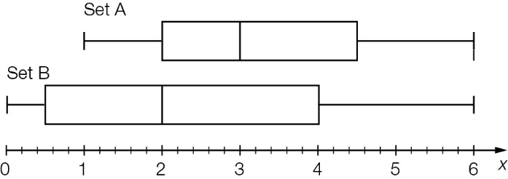

(b) Compare the statistics for the two data sets.

Question 4 (4 marks)
Plot the following points onto the graph and describe the relationship between x and y.
(1, 3), (1, 2), (3, 3), (4, 1), (5, 2), (6, 1), (7, 0), (8, 1)

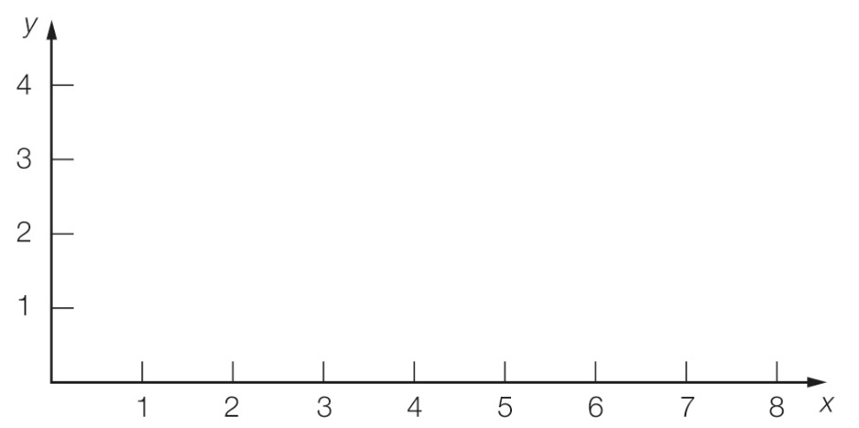

Question 5 (4 marks)
Show how $10 000 invested at 8% p.a. for 2 years can earn different amounts of interest by using at least two different time periods to compound the interest.

Question 6 (2 marks)
$5500 is borrowed at 9.5% pa simple interest. $2090 in interest is repaid with the loan.
How long did it take to repay the loan?

Question 7 (4 marks)
The share price for a volatile stock was recorded each hour for a six-hour period.

Time | 1 p.m. | 2 p.m. | 3 p.m. | 4 p.m. | 5 p.m. | 6 p.m.
Price | $1 | $2 | $2.50 | $1.30 | $1 | $0.80

(a) Draw a scatter plot of the price of the stock on the graph below.
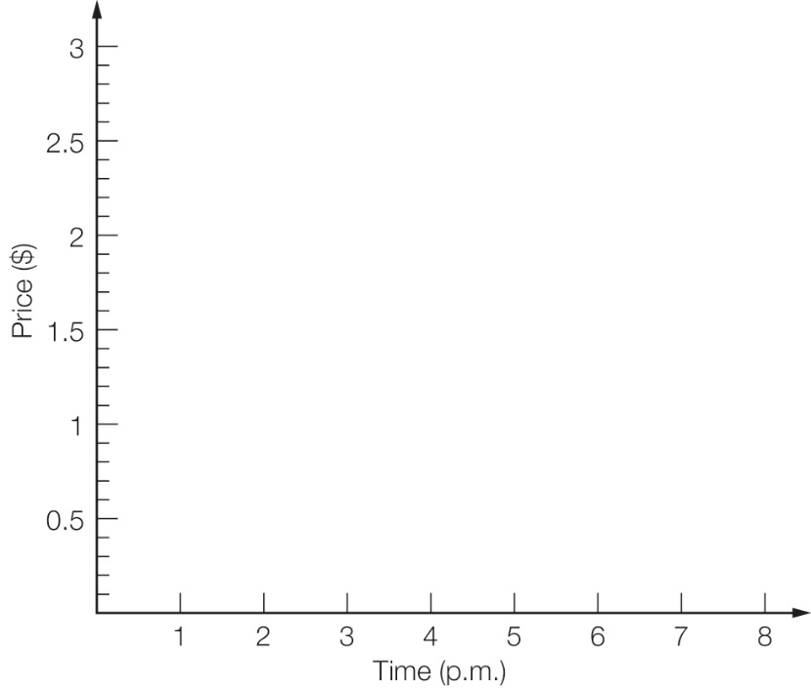
(b) Describe the price movement of the stock over the six-hour time period.

Question 8 (2 marks)
At what simple interest rate will an investment of $6500 grow to a total investment of $9750 in 8 years?

Question 9 (4 marks)
A deposit accumulates to $10 000 in 2 years. The interest is paid at 10% p.a. and compounded half-yearly. Calculate the initial deposit to the nearest dollar.

Question 10 (6 marks)
A $10 000 investment is placed in a bank returning 6% compound interest. Find the value of the investment, correct to the nearest cent, after a year if interest is calculated every:
(a) six months

(b) month.

Question 11 (6 marks)
$25000 is invested for 4 years. Calculate the compound interest earned on each of the following.

a) 7% pa compounded annually.

b) 2.75% compounded monthly.

Question 12 (4 marks)
Will and Grace both invest $2000 for 6 years. Will’s investment compounds annually at 5% and Grace’s investment pays simple interest at the rate of 5%. Who has the most money at the end of the 6 years and by how much? Why is this?

